**Demo on Pending Points from Discount Schedule –**

1. Create Term based Discount Schedule
2. Create Cost based Discount Schedule

**Contracted Pricing:**

Picture this scenario: You've successfully sold a specific product to a customer for $1000. Now, whenever the customer renews the contract, you want to maintain this price, regardless of any changes in the price book. Salesforce CPQ has a perfect solution for this called **Contracted Pricing,**a feature that operates at the account level.

With this feature, you can ensure that the agreed-upon price remains fixed throughout the contract's duration, providing your customer with pricing stability and preserving your business relationship.

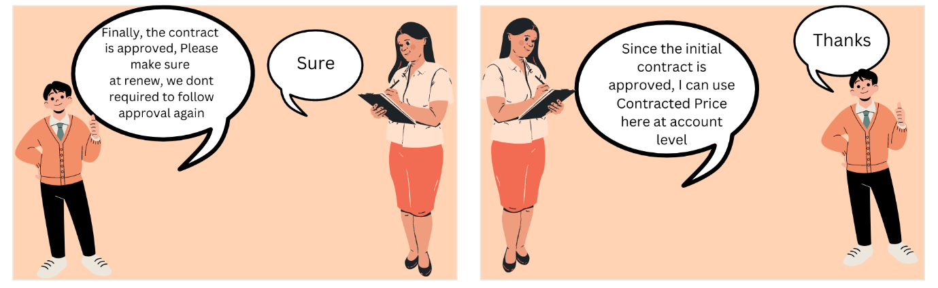

**Contracted Pricing Important Fields:**

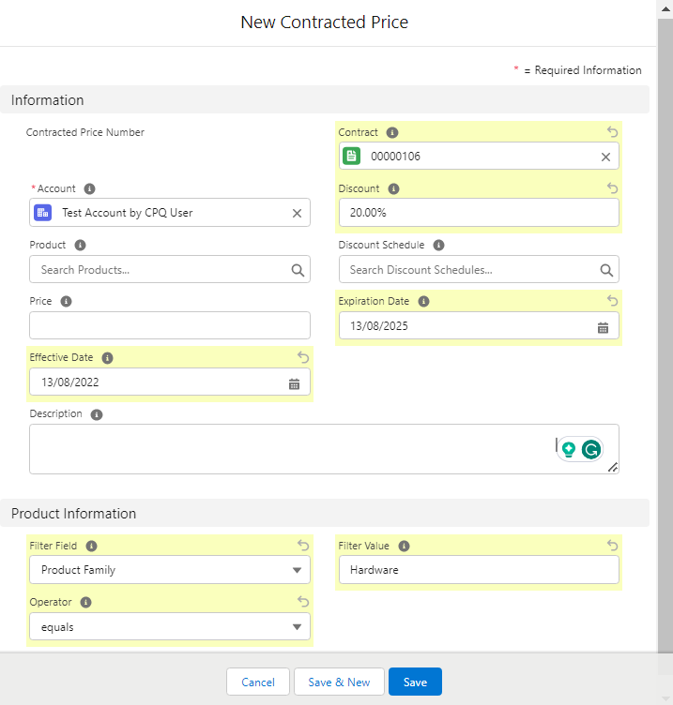

* **Product**: Select the product for which this special pricing needs to be applied.
* **Price:**This is the special price, it will be the fixed price for the subscription-based product and non-subscription-based products
* **Discount**: Add the numeric value in Percentage.
* **Discount Schedule**: This discount schedule will override the discount schedule at the product level. This is specific to the account or customer that you are selling to.
* **Effective Date and Expiration Date**: These define the start date and end date when the contract pricing is applicable.
* **Product Information:**Based on Filter Field, Filter value, and Operator value the filter will be applied to the Product object. Discount will be applicable to those filtered all products.

During quote line price calculation, Salesforce CPQ checks whether your quote line has contracted price. If it does, Salesforce CPQ passes that price to your quote line's special price. It then updates the quote line's Special Price Type field to Contracted Price.

**Steps to configure Contracted Price: (Manual Creation of CP)**

1. Go to the Account tab and create/edit any account. Go to the related tab and click on the new button under Contracted Prices
2. Add the following values-  
   **Discount:**20%  
   **Expiration Date: A**dd any future date  
   **Effective Date:**Add today's date  
   **Filter Field:**Product Family  
   **Filter Value:**Hardware  
   **Operator:**Equals  
   Savethe record.
3. Go to the quote tab and create or edit any quote. Add the account that we have created in step 1
4. Click on the Edit line button and add any Hardware type product. You will observe all hardware-type products are applicable for a 20% discount. If you add the same product(s) to any other quote it will show the price without any discount. Let's check this demo -



**Automatically Create:**

1. From a quote. select a value for the Generate Contracted Price field.

• **Price**: The contracted price has a price field equal to the net unit total for this product's quote line. All future quote lines for this product on this account use this price as their initial price.

• **Discount Schedule**: The contracted price doesn't provide a value for the Price field. Instead, the contracted price record inherits the quote line's discount schedule. All future quote lines for this product on this account receive prices based on this discount schedule.

• **Do Not Generate**: Salesforce CPO doesn't create a contracted price for this product

2. Save your quote record.

When you contract your quote, Salesforce CPQ creates a Contracted Price record in your account for every product on your quote. The contracted price is based on the value in the Generate Contracted Price field.

FYI-

If a product is already contracted and contract price is added, you cannot create another contracted price automatically (You can do it manually though). You will get this mail from salesforce if you try to create duplicate contracted price under same Account - 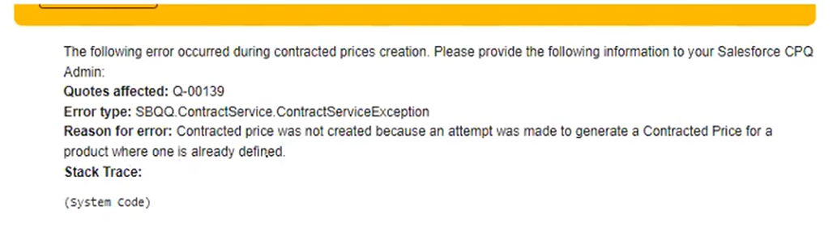

**Salesforce CPQ does not create a contracted price under the following** –

* The product is present in two or more quote lines, where each quote line has a different price or discount schedule.
* The product exists as an MDQ product with different discount schedules in two or more segments.

**Considerations**:

* Discount Schedule Set on Contracted price Overrides one on product when a contracted price is applied on the quote line.
* "Contracted Price" lookup gets populated with the contracted Price record.
* "Special Price Type" field is set to Contracted price.
* When setting Price take into consideration default subscription term
* Set only 1 Contracted price per product (Preferable to set generate contracted price on the quote rather than product)
* When Using a filter to identify the Products, Use the Discount %
* Can Inherit through Account Hierarchy by cascading down the hierarchy
* When it conflict the one set at lower-level wins over higher level you can set ‘ignore parent contracted price’ at account level if needed
* You can retrieve Contracted Price from an alternate Account by creating the CPQ special field ContractedAccountID__c, on Quote (Set as Account Lookup or Formula So that it stores the ID f alternate Account)